MICROSOFT CMT
A Step-by-Step Guide for Authors

Table of Contents

1 CMT ACCOUNT CREATION 3
1.1 If you already have a CMT Account: 3
1.2 If you are new to CMT, 3
2 NAVIGATION 6
2.1 Registration Link 6
2.2 Scan QR Code 6
3 PAPER SUBMISSIONS 6
3.1 Author Console 6
3.2 New Submission 6
3.3 Adding Co-Authors 7
3.4 Changing Corresponding Authors 7
3.5 Selecting Subject Areas 8
3.6 Uploading Files 8
3.7 Changing Uploaded Files 8
3.8 Author Declaration and Agreement 9

CMT ACCOUNT CREATION
This document is a step-by-step guide for authors who are interested in submitting their research work to CEURS 2023.

If you already have a CMT Account:

Please use the following link to submit your paper to CEURS 2023:
https://cmt3.research.microsoft.com/CEURS2023

OR

If you are new to CMT,

• Follow the guidelines to make a new account and add your submission.

REGISTRATION IN CMT
- Here, Click the Register Button since you are newly registering an account.

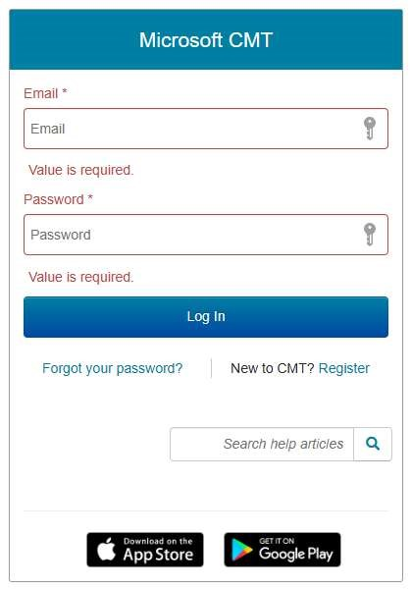

Figure 1. CMT Registration Window
- Then you will see a create account window in the next step.

CREATING A NEW ACCOUNT
- Fill out the “Create New Account” page with your relevant information.
- Fields with an asterisk “*” are required, while the others are optional.
- After completion, click on the “Register” button at the bottom of the page.
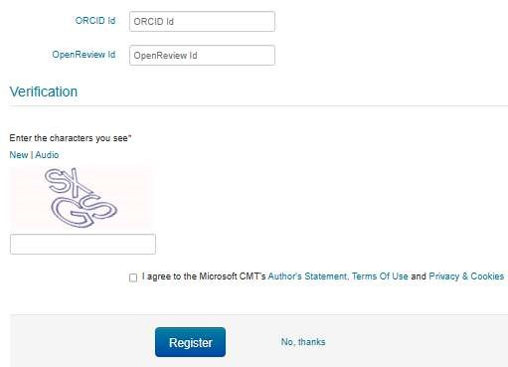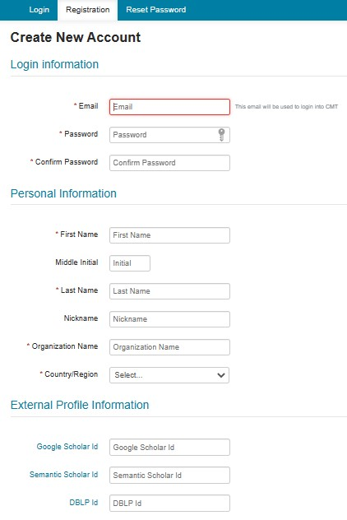

Figure 2. Creating New Account

REGISTRATION COMPLETION
- Once you complete your registration correctly, the page will appear like this,
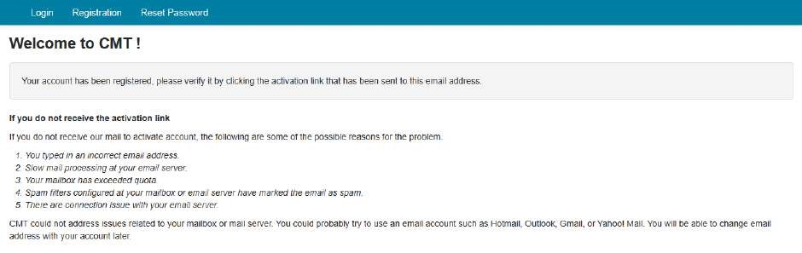
Figure 3. Registration Complete
- Now, you will receive an account verification email from Microsoft CMT to your given email address.
- Log in to your email account and click on the email verification link to verify your email address.
- If needed, you can update your email address and account details with your CMT account.

You have successfully created a Microsoft CMT Account!

NAVIGATION

Registration Link

• Click on the following link and navigate to the “Register” page of the CMT.
https://cmt3.research.microsoft.com/CEURS2023

OR

Scan QR Code
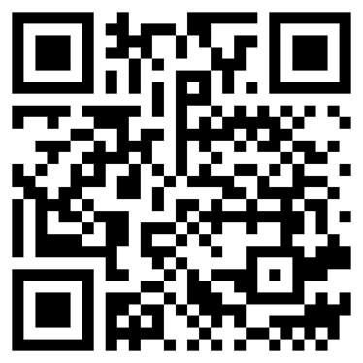
Figure 4. Registration Link QR Code

PAPER SUBMISSIONS

Author Console
- First, log in to your CMT account.
- Now Click on the following link https://cmt3.research.microsoft.com/CEURS2023
- Then you will see the “Author Console Page”. Click on the “Create new submission” button.
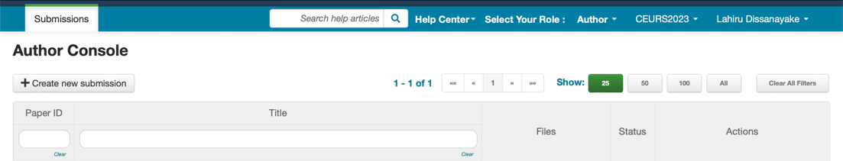

Figure 5
.
Adding New Submission

New Submission
- Once you select the “Create New Submission” button, it will move to the “Create New Submission” page.
- Now complete the required information in the submission form.
- Enter your research title in the “Title” Filed
- In the “Abstract” field, enter the summary of your research work (Abstract of the research). It allows a maximum of 3000 characters only.
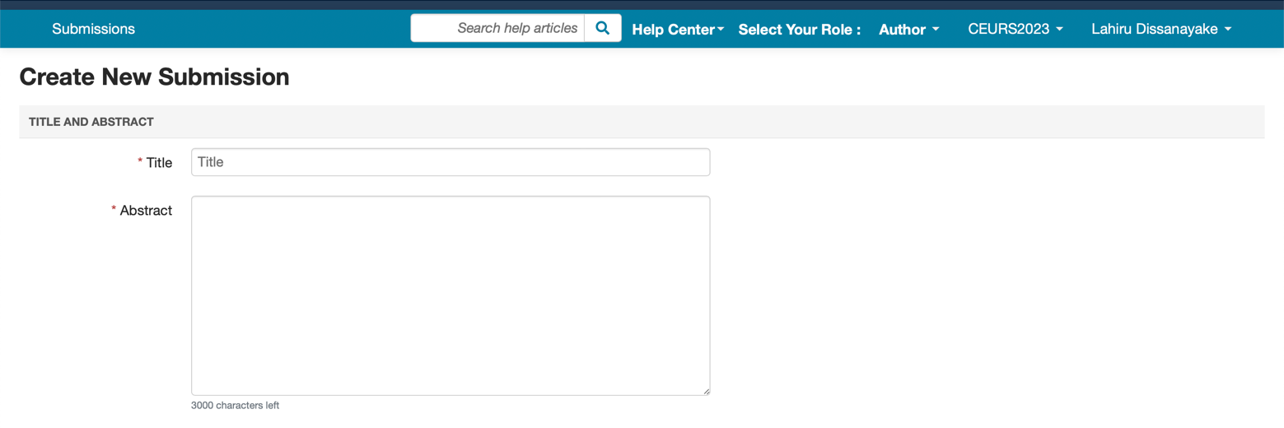

Figure 6
.
Adding Title and Abstract

Adding Co-Authors
- To add a co-author, enter the email address of the co-author in the “enter email to add new author” field and click on “Add”.
- Here, you have to add all the co-authors of your research. It is not compulsory for all coauthors to have a CMT account. If a co-author already has a CMT account, the details pertaining to that co-author will appear automatically. If not, you can insert the details manually.
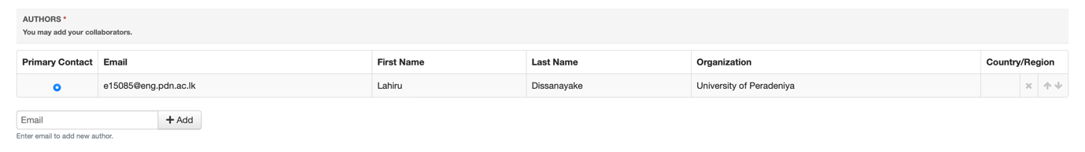

Figure 7
.
Adding Co
-

Authors

Changing Corresponding Authors
- You can change the primary contact (Corresponding Author) by clicking on the Primary Contact radio button in the co-author’s field.
- If you need to change the order of the list of authors, use the up and down arrows in the right corner.

Selecting Subject Areas
Since the CEURS 2023 has 3 Subject Areas, the area relevant to your research paper needs to be selected before submission.

Figure 8. Selecting Subject Area

Uploading Files

- To upload file/s to your research, click on the “Upload from Computer” button and select the file/s you needed to upload.
OR
- You can drag and drop your file/s into the dotted region here.
- CMT allows you to upload files only in Word file formats.
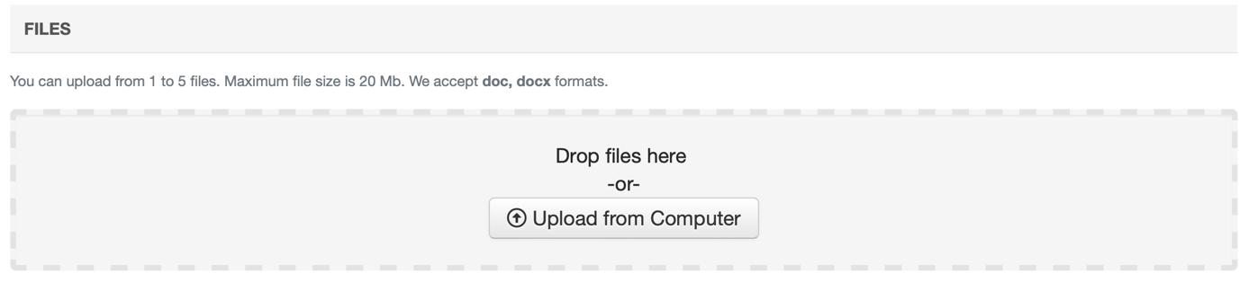

Figure 9. Upload or Dragging and Dropping Files

Changing Uploaded Files
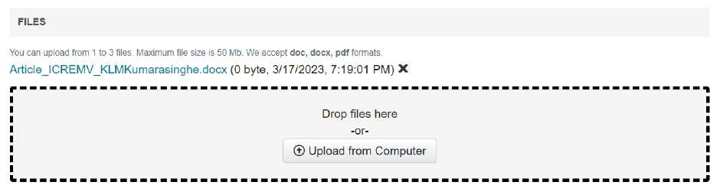
•

Uploaded file/s are visible and
editable.

Figure 10. Changing Uploaded Files

Author Declaration and Agreement
Then click on the “I agree” check box for the author declaration, and then click on the “Submit” button to complete your submission.

Figure 11. Author Declaration
Then, the page will move to the “Submission Summary” page.
- All the details about the submission of your paper will appear here. If necessary, you can edit your submission using the “Edit Submission” button given at the bottom of the page.
OR
- You are able to move into the Author Console page by clicking on the “Back to Author Console” button.
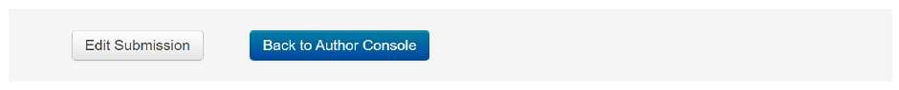

Figure 12. Back to Author Console

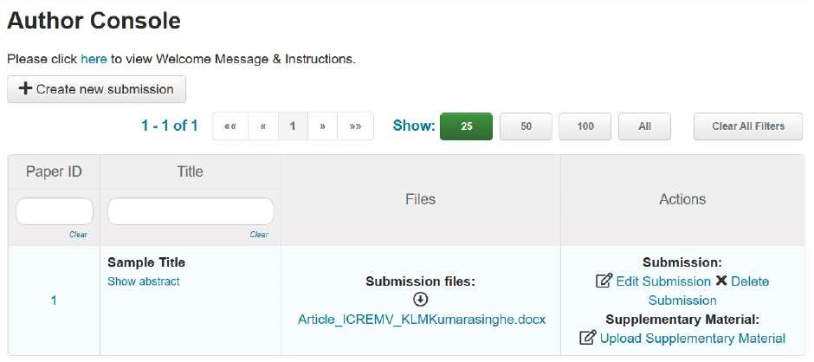
Figure 13. Author Console

- You can add your Author Declaration form as a Supplementary File to support your submission through the “Upload Supplementary Material” link.
- Now you have successfully completed your submission for CEURS 2023.
- You will receive emails from the organizers of CEURS 2023 with updates about your submission. You can check your Author Console at any time to get to know about the latest updates on your submission.

Thank you!

