Instructions to Students about Extended Abstract (Use Heading 1)

Student 1, Student 2, Supervisor (Use Normal without credentials)

Keywords (Heading 3): Engineers, Guideline, Template

1. Introduction (Heading 2)

This document is intended to serve the dual purpose of providing instructions to students and acting as a basic template for modifying the text and expanding to form abstracts in the required format. (All the contents should be typed in normal style. For headings use the style mentioned in brackets)

2. General Information

- The paper must be an Original Technical Paper based on research by the author(s) or an Original Article of Professional or Technical interest.

- Extended abstract should not contain any derogatory remark/s whatsoever about any person or organization.

- Presentation of the paper should be in ‘Third Person’

- It is preferable that International System of Units (SI) be used. If other units are used, relevant SI unit should be given within brackets or in a supplementary dual unit table.

- The final version of the Extended abstract should be submitted to symposium web page in soft form (MS-Word format).

3. Format

The proceedings will be published in standard A4 size with two-column layout for text. Diagrams and tables should be in portrait orientation with either one or two column width.

3.1 Size of the Abstract
Size of the abstract composed in the required format is limited to three to four (3-4) pages.

3.2 Font and Margins
The Font for general text should be ‘Book Antiqua’ with 10-point size. Major heading shall be with the same font of 14-point size, bolded while minor sub headings shall be 12-point size, bolded. Major and minor sub headings should be numbered in the manner adopted in this paper. For other sub headings use 10 point bold font style.

Margins shall be 20 mm all around and an additional binding gutter of 10 mm on the appropriate edge. Width of a text column shall be 75 mm with a space of 10 mm in between.

3.3 Headings and order of presentation
The authors are free to name headings according to the context and content of the paper. However, it is preferable to have main headings in the following order for consistency.

Introduction
Literature Review
Methodology
Results and Discussion
Conclusions

References

References (all cited in main text), should not be given a paragraph number. Either References or Bibliography may be used.

3.4 Limitations due to the Format
Due to the adopted format, authors are advised not to use ‘headers’, ‘footers’ or ‘foot notes’.

4. Presentation

For the message delivered by the article to be more effective, the text should be supplemented by ‘tables’, ‘figures’ ‘equations’ & ‘photographs’ as appropriate and references to other publications.

4.1 Tables
Tables should be either one or two column width in portrait orientation. Each table should be sequentially numbered and titled above its top.

Table 1: Mean reference values of ME of Rice polishing obtained by different researchers
Different research (Year) | ME kcal/kg
Choo and Sadiq (1982) | 2970.00
Ghazi (1992) | 3740.69
NRC(1994) | 3090.00
Nadeem (1998) | 3016.00
Leeson and Summers (2001) | 2750.00
Hanif (2006) | 2237.00

4.2 Figures and Photographs
Figures and photographs should be either one or two column width in portrait orientation with high resolution. Each figure should be sequentially numbered and titled below. Figures should keep in line with text

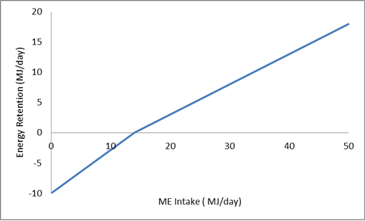

Figure 1: Efficiency of utilization of metabolizable energy

4.3 Equations (Mathematical Expressions)
Equations should be indented and separated from the text and identified by consecutive numbers placed at the far right side of the line within brackets.
(e.g.: ……………….......(3))

4.4 Citing References
Use Harvard referencing format.

5. Conclusions

It is expected that by complying with the simple guidelines presented in this paper, the authors would be able to present their research and professional articles in a logical and coherent manner so as to comply with accepted standards.

References

This section should include all the references made in the paper and in the Harvard referencing format.
https://www.mendeley.com/guides/harvard-citation-guide/

